Revision History
Date | Version | Description | Author
25/11/2023 | 1.1 | The overall architecture design discussed, and document parts are divided. | Kerem Bekmez,  Mehmet Kutlutan,  Ahmet Pehlivanoglu,  Azra Acil,  Sevval Kurt
26/11/2023 | 1.2 | Software Architecture Overview and COTS modified | Mehmet Kutlutan
27/11/2023 | 1.3 | Vehicle View Diagrams and software requirements mappings are updated | Ahmet Pehlivanoglu,  Azra Acil
28/11/2023 | 1.4 | Vehicle Model Diagrams and software requirements mappings are updated | Sevval Kurt
28/11/2023 | 1.5 | Vehicle Controller Diagrams and software requirements mappings are updated | Kerem Bekmez
04/12/2023 | 1.6 | Section 2 labels of dependencies changed based on the feedback | Mehmet Kutlutan
05/12/2023 | 1.7 | Realization Arrows replaced Direct association in the section 3.3.2 | Kerem Bekmez
06/12/2023 | 1.8 | Component design of Vehicle Model updated to satisfy the interface based on the feedback | Sevval Kurt
07/12/2023 | 1.9 | View Workflow updated to ensure function consistency within objects. | Azra Acil

TABLE OF CONTENTS
Revision History 1
1 Introduction 3
1.1 References 3
1.1.1 Project References 3
2 Software Architecture overview 3
3 Software design description 3
3.1 Vehicle View 3
3.1.1 Component interfaces 3
3.1.2 Component design description 4
3.1.3 Workflows and algorithms 5
3.1.4 Software requirements mapping 5
3.2 Vehicle Model 5
3.2.1 Component interfaces 5
3.2.2 Component design description 6
3.2.3 Workflows and algorithms 6
3.2.4 Software requirements mapping 7
3.3 Vehicle Controller 7
3.3.1 Component interfaces 7
3.3.2 Component design description 8
3.3.3 Workflows and algorithms 9
3.3.4 Software requirements mapping 9
4 COTS Identification 10

Introduction

This document describes the design of the VRS software system.

References

Project References

# | Document Identifier | Document Title
[SRS] | VRS-SRS-1 | VRS Software Requirements Specifications

Software Architecture overview
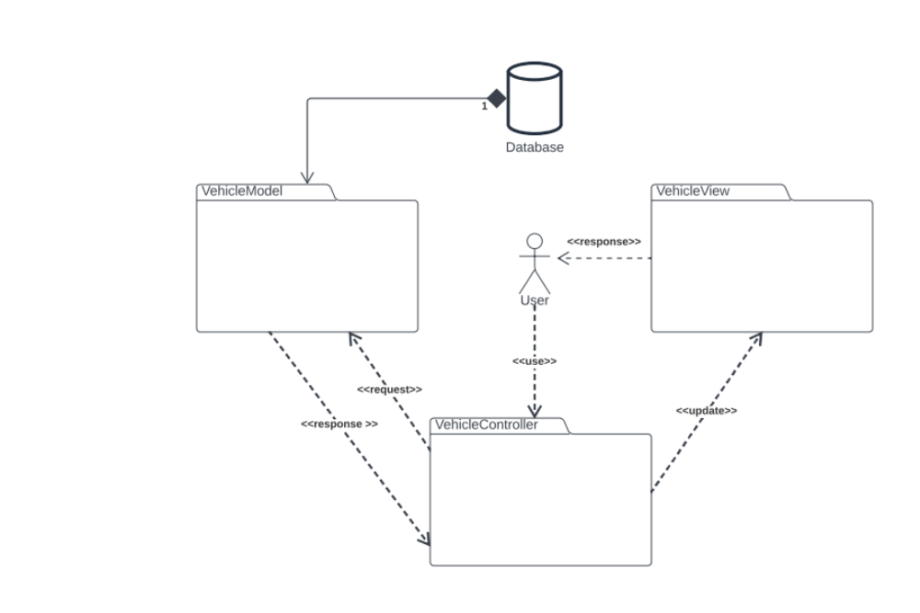

Software design description

Vehicle View

Component interfaces
User interface components are meticulously structured to ensure an intuitive and efficient user experience. Upon initiating the application, users are presented with a login interface. This interface is designed for users to securely access their accounts by entering a username and corresponding password. For new users, a 'Sign Up' button is available, so that they can create a new account. This process requires the submission of a unique username and a password.

Once logged in, users are directed to the main page of the application. Here, a personalized welcome message is displayed, indicating a sense of user engagement. This interface includes a comprehensive listing of available vehicles. To enhance the user's ability to efficiently navigate through the vehicle options, a filtering mechanism is integrated. This feature allows users to refine their search based on various parameters such as color, vehicle type, rental dates etc.

Furthermore, there exists a box that shows the user’s current financial balance, enabling them to make informed decisions about vehicle selection and rental duration based on their budget.

The vehicle rental process is streamlined for ease of use. Upon selecting a vehicle and determining the rental period, the 'Rent' button is enabled. Clicking this button initiates the rental process, and upon successful completion, a confirmation pop-up is displayed, affirming the transaction.

An additional feature is a navigation button that brings user to rental history page with access to their rental history, enhancing the personalization aspect of the application. User can navigate between rental history page and main page using navigation buttons.

Component design description
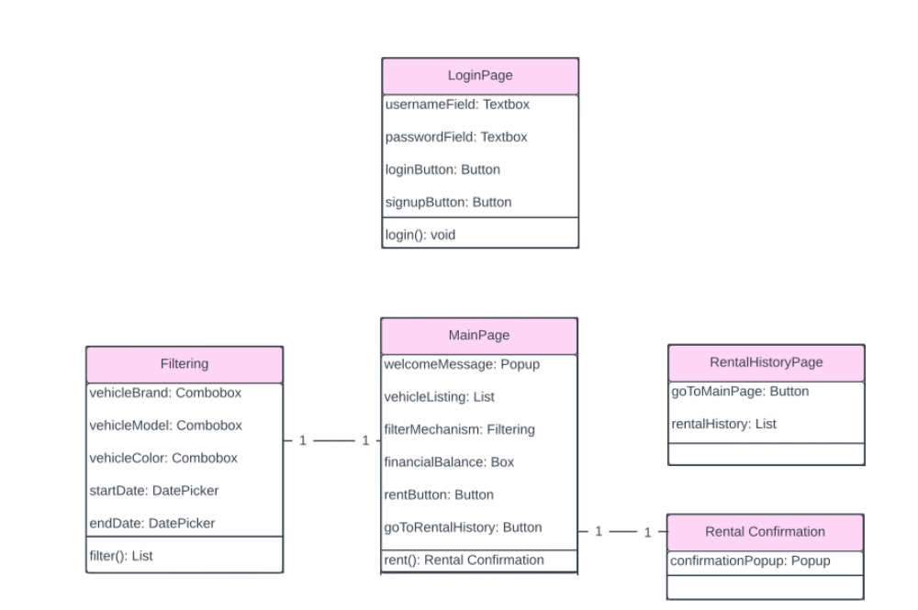

Workflows and algorithms
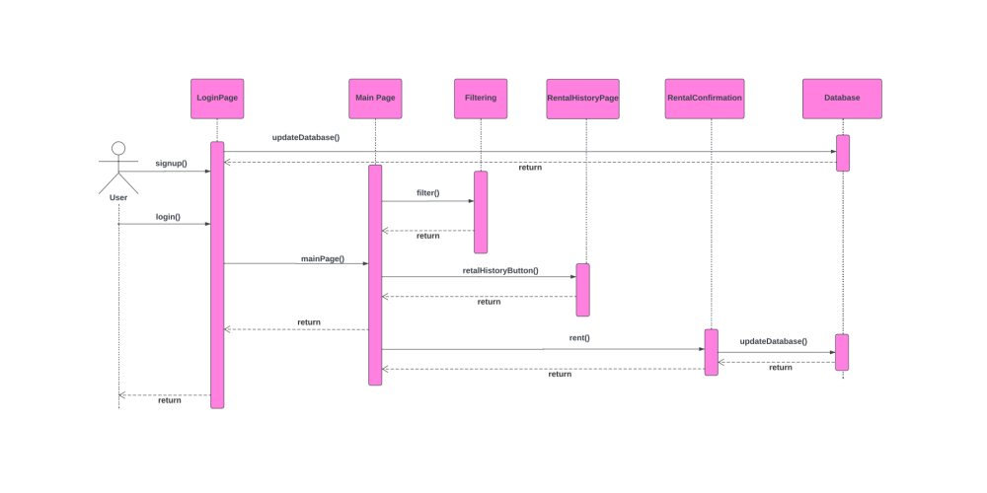

Software requirements mapping
SRS-VRS-001
SRS-VRS-002
SRS-VRS-005
SRS-VRS-006
SRS-VRS-007
SRS-VRS-008

Vehicle Model

Component interfaces
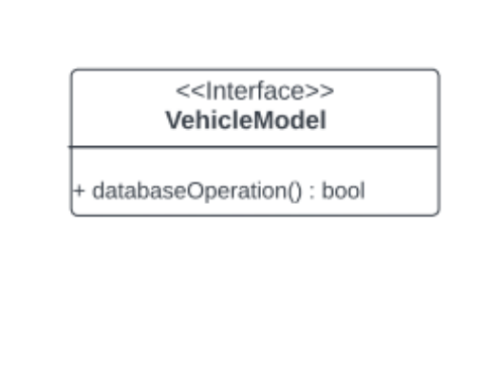

Component design description
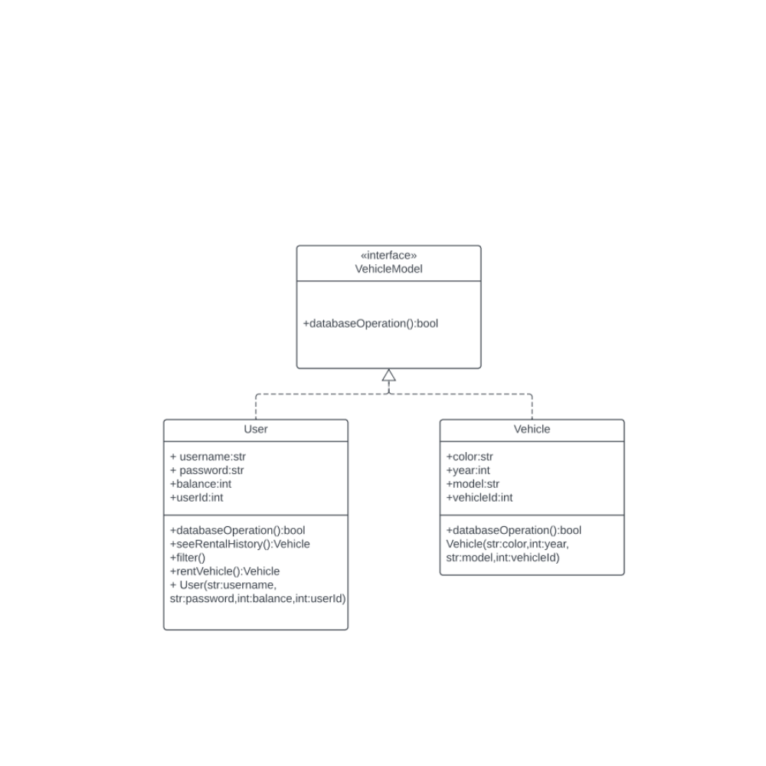

Workflows and algorithms

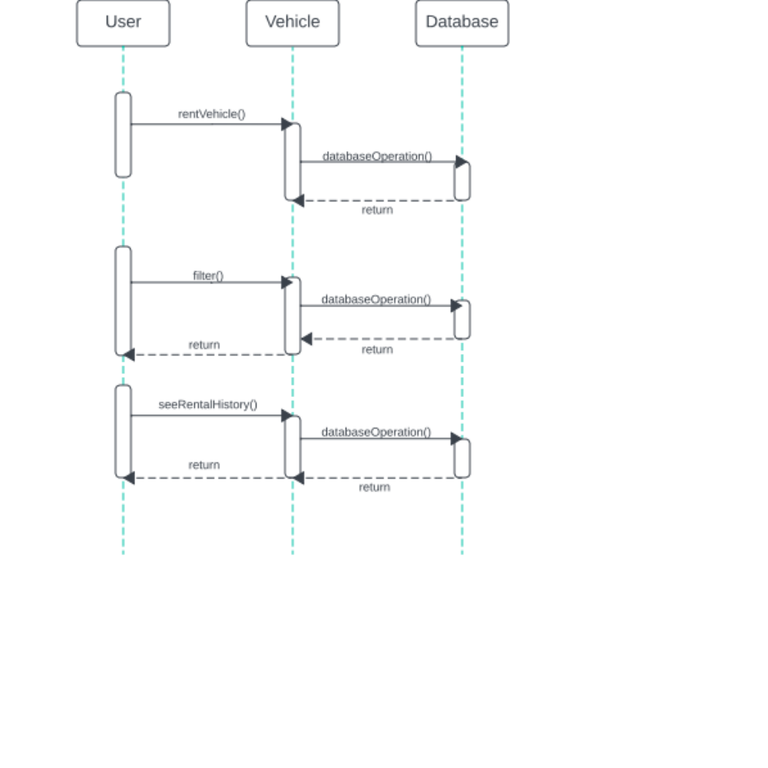

Software requirements mapping
SRS-VRS-003
SRS-VRS-004
SRS-VRS-006
SRS-VRS-007
SRS-VRS-008
SRS-VRS-011

Vehicle Controller

Component interfaces

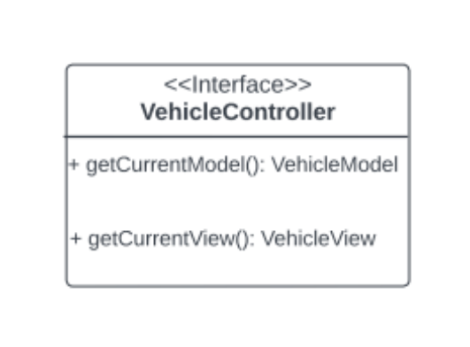

Component design description

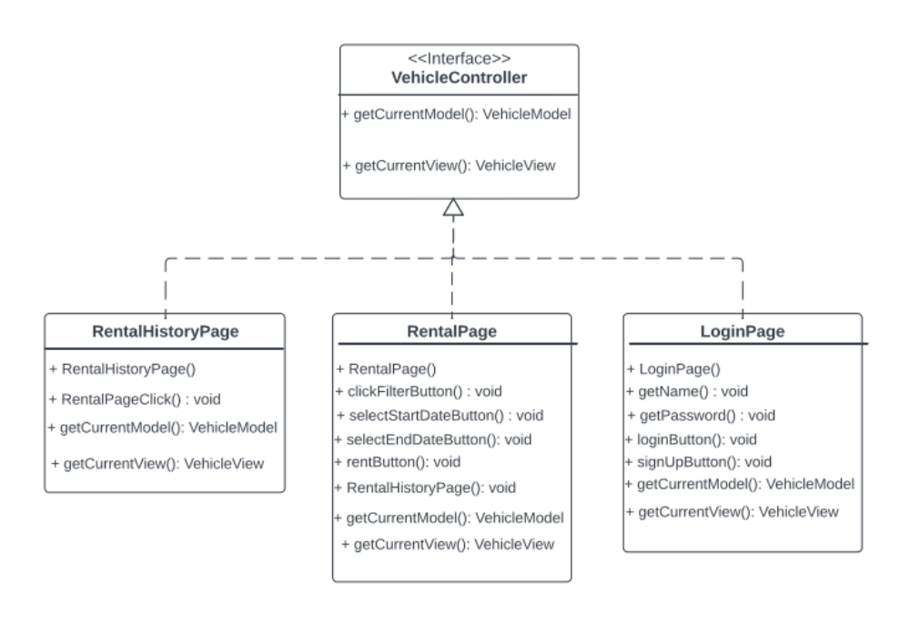

Workflows and algorithms
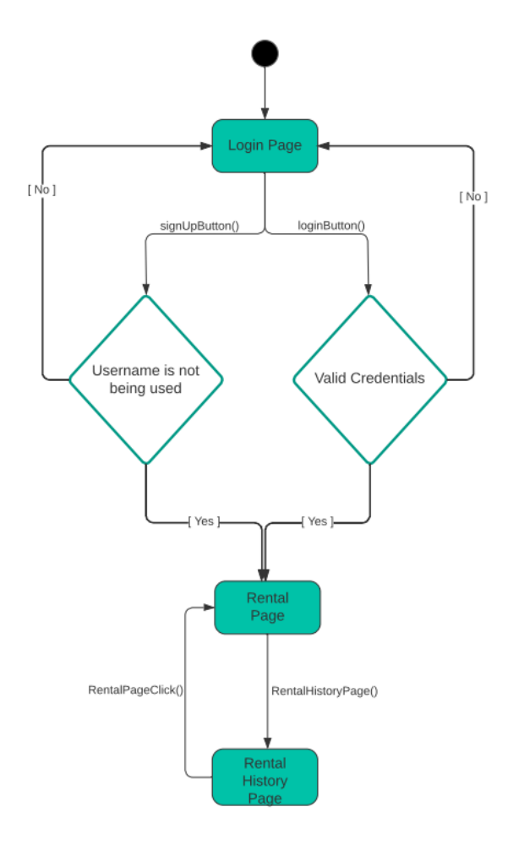

Software requirements mapping
SRS-VRS-001
SRS-VRS-002
SRS-VRS-008

COTS Identification
COTS (commercial of the shelf) libraries used in VRS are the following:
• MySQL
• Java
• Java MySQL connector
• Tomcat
• HTML
• Spring
• Bootstrap

